Student Motivation and Classroom Tools

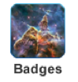
What are badges?
Badges are a great way to keep students motivated! Students earn a badge for every 100 correct problems answered in math, language, and reading. Students can see and read about their badges by clicking “Badges” button.

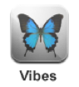
What are vibes?
Moby Vibes can help manage behavior in the classroom. Use vibes to reward good behavior, curb bad behavior, and give your students specific feedback as they work in class. Teachers can customize vibes to meet the needs of their own classroom.

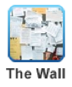
What is the wall?
Moby's wall is a different way to communicate with your entire class. Teachers can post messages, create assignments, schedule events, and poll students on questions. Students can comment on posts and download class materials.

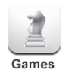
Games
Students earn game time for the amount of time they spend passing practice sets in MobyMax.

To change how much time students earn:
1. After signing in to your teacher account, click "My Settings."
2. Click "My Modules."
3. Change the game settings.
4. Click the "Save" button.
You can also manually adjust how much game time a student receives.
1. After signing in to your teacher account, click the "Games" button.
2. Click the notepad icon next to the student's accumulated game time.
3. Change the accumulated game time.
4. Click the "Save" button.

Why can’t students see all the games?
Some of the games require updated browsers or Flash to work. The following games are available on the listed browsers:
- Up to date internet browsers with Flash plugin: all games
- iPad, Kindle, and other mobile devices: NutMeg, AlienBio
- Internet Explorer 7&8, and older versions of Firefox: MathMan, Montris

