MobyMax:
Viewing Individual Student Math Progress by CCSS

First, sign into your MobyMax account.

Step 1: Click Math
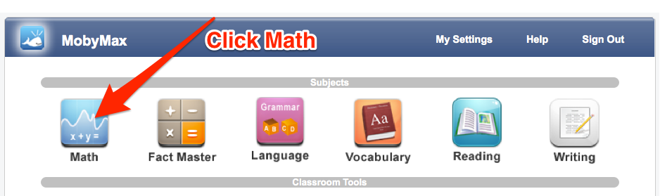

Step 2: Click Progress
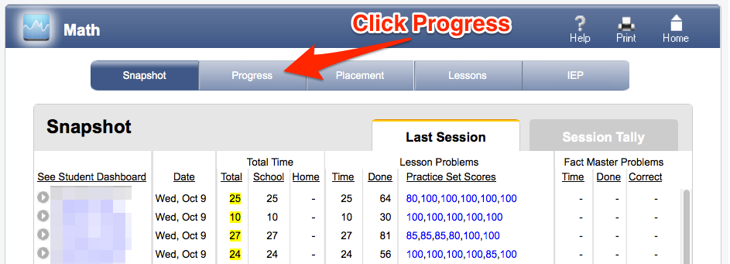

Step 3: Choose Student
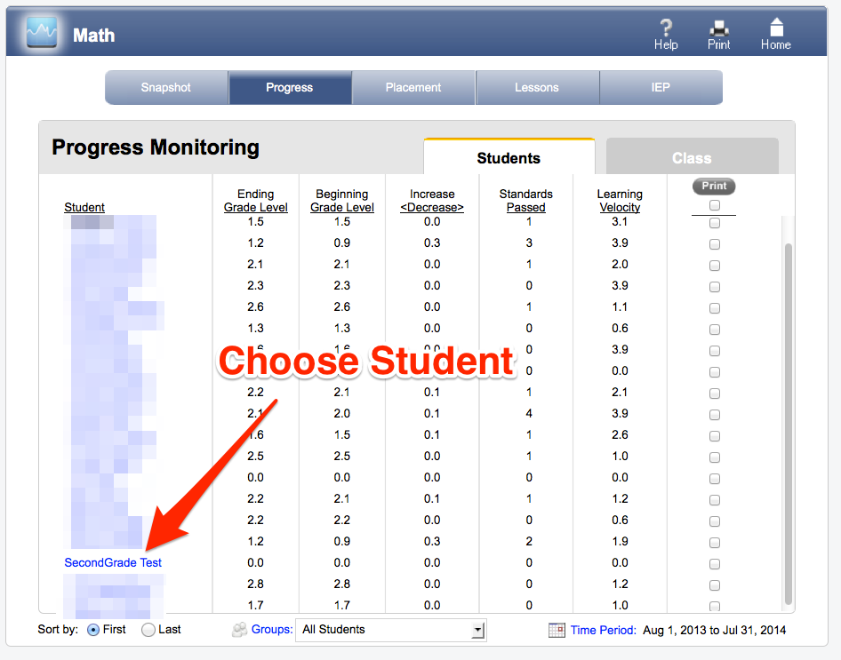

Step 4
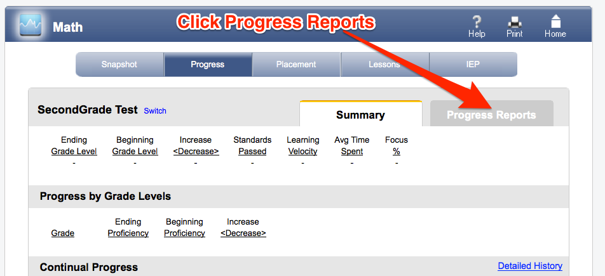

Step 5: View Standards by Grade Level
